DIRECTORATE FOR STANDARDS, METROLOGY AND QUALITY  VIETNAM CERTIFICATION CENTRE - QUACERT  No /QUACERT-TH  On using certification marks of  ISO 9001:2008 | SOCIALIST REPUBLIC OF VIETNAM  Independence - Freedom - Happiness  Hanoi, dated ……., 20…

To:

In order to propagate, promote and affirm that the Information Security Management System of your Company has been certified to ISO 9001:2008, the Vietnam Certification Centre – QUACERT would like to send to you the certification mark as shown below:

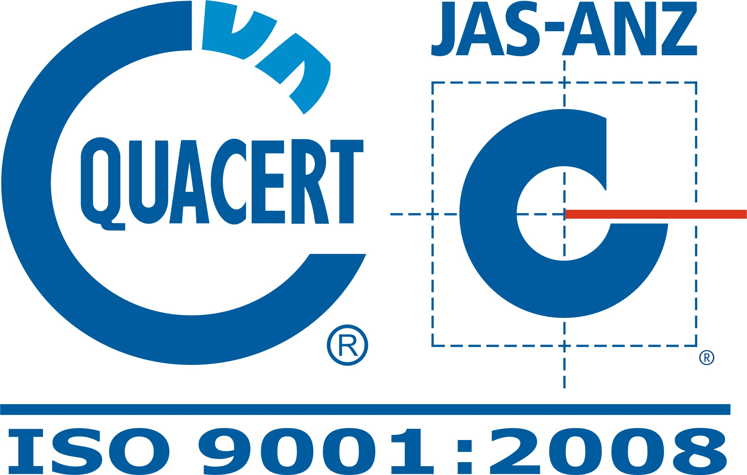

1. Certification mark shall be used in the following cases:
- on letterheads, transaction documents, technical documents, training materials, brochures, name-cards, media, promotional materials, vouchers and marketing materials;
- in the advertising, promotion in the mass media such as radio, television, press...;
- on the transportation means, public billboards,...
2. Certification mark shall not be used in the following cases:
- directly on the products or packaging materials;
- misleading that the legality of a product trademark has been certified by QUACERT or any other misleading manner;
- misleading that QUACERT has certified for specific products;
- certification expired, suspended, withdraw or reduced partially or when the ISMS is not complying with the certification requirements;
3. Notes for using:
- The certification mark shall be printed exactly with described specific colors or single color to suite the printed material such as documents, newspaper, magazin or other materials;
- The certification mark can be zoomed in or out rationally, provided that the text can be read clearly.
- The Certificate and Certification Mark cannot be transferred.

DIRECTOR

